***The Tragedy of Flight: A Comprehension Crash Analysis***

**Introduction:**

The aviation industry is an essential industry that contributes significantly to global economic growth. However, when a fatal accident occurs, the devastation it causes is significant, resulting in the loss of life, financial damages, and negative media coverage. Crash analysis aims to identify the factors that contribute to an accident to prevent similar occurrences in the future.

**Purpose:**

The purpose of conducting an airplane crash analysis typically involves the collection and analysis of a wide range of data, including information about the aircraft and its systems, the operators, and any other relevant factors. Once the data has been collected, it is analysed through tableau, to identify any potential causes of the accident. The results of an airplane crash analysis are typically published in a report, which may include recommendations for improving safety and preventing similar accidents in the future. These recommendations may be implemented by the relevant authorities or industry organizations.

**The dataset given in our project is from the year 1908-1945.** This dataset includes:

* All civil and commercial aviation accidents of scheduled and non-scheduled passenger airliners worldwide, which resulted in a fatality (including all U.S. Part 121 and Part 135 fatal accidents).
* All cargo, positioning, ferry and test flight fatal accidents.
* All military transport accidents with 10 or more fatalities.
* All commercial and military helicopter accidents with greater than 10 fatalities.
* All civil and military airship accidents involving fatalities.
* Aviation accidents involving the death of famous people.

**PROBLEM DEFINITION AND DESIGN THINKING**

**Empathy map:**

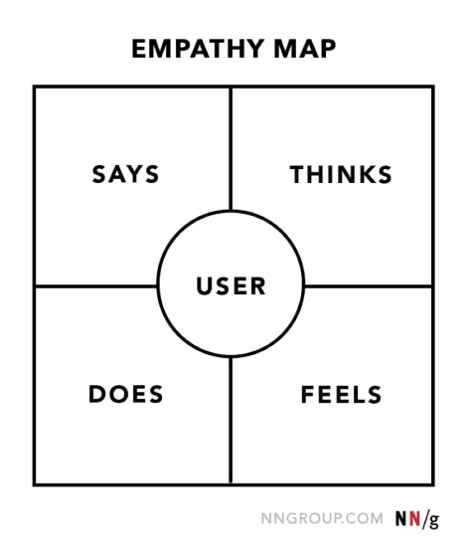

An empathy map is a tool used to understand the feelings and experiences of a specific type of user or customer. The aim of an empathy map is to get inside the head of a user or customer to gain a better understanding of their thoughts, feelings, goals, and pain points. Empathy maps are especially useful in developing products and services that meet the needs of the intended audience by providing valuable insights to designers, marketers, and product managers. By using empathy maps, teams can focus on creating solutions that are more targeted and relevant, which can lead to greater success in product development and customer satisfaction.

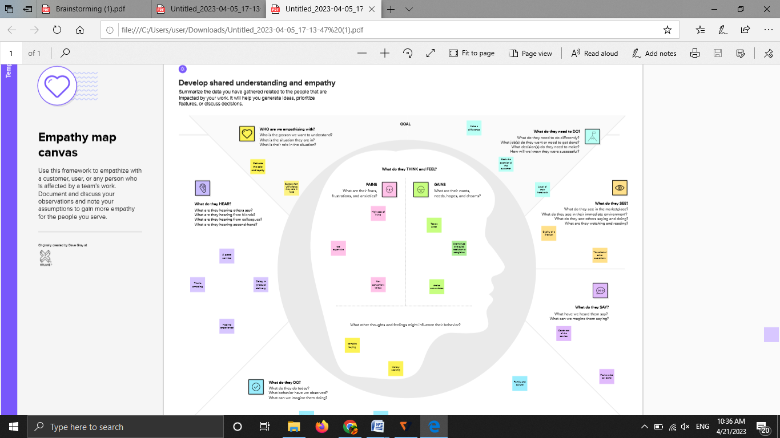

Brainstorming:

Brainstorming is a technique used by individuals or groups to generate a large number of creative ideas or solutions to a specific problem or challenge. The purpose of brainstorming is to generate as many ideas as possible in a short period of time, without judgment or criticism.The primary use of brainstorming is to encourage creativity and innovation in problem-solving. It is a powerful tool in the business world for generating new ideas, improving products or services, and identifying new opportunities for growth.

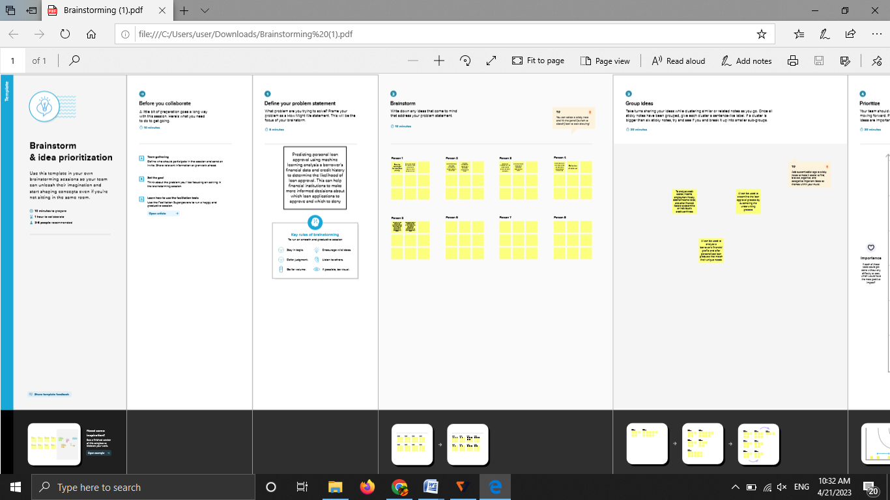

Tableau supports many different data sources including MySQL because Tableau is designed to connect to and work with a wide range of data sources. MySQL can be used as a data source in Tableau, meaning that data stored in a MySQL database can be easily visualized and analyzed using Tableau’s powerful data visualization features.

By connecting Tableau to a MySQL database, one can create dashboards and reports that display data from MySQL tables, views, or queries. When connecting to MySQL, Tableau automatically discovers the tables and gives the option to select which tables to use as data sources.

Tableau can also manipulate and transform the data from MySQL within the visualization software. It provides various methods to filter, group, pivot and aggregate…

To represent a report consisting of airplane crashes from the year 1908-1945, we created a tableau dashboard that displays the following information:

1. Geographic location of the crash

2. Date of the crash

3. Type of aircraft involved

4. Number of casualties (injured/killed)

5. Cause of the crash

**Advantages of Tableau for preparing business analysis:**

* **Data integration:** Tableau can connect to various data sources and allows users to visualize data from different sources together, which can help to gain a more comprehensive view of the business.
* **Data Visualization:** Tableau allows users to create interactive dashboards, which are visually appealing and can help to present complex data in simple ways, making it easy to understand.
* **Quick analysis:** Tableau provides quick insights, allowing users to gain insights from data instantly, empowering them to make evidence-based business decisions.
* **Real-time data:** Tableau can provide real-time data, which can help users to quickly identify and respond to business challenges.
* **Collaboration:** Tableau makes it easy for teams to collaborate, share insights, and collaborate on projects in real-time.

**Disadvantages of Tableau for preparing business analysis:**

* **Learning curve:** Tableau may require a significant time investment and has a relatively steep learning curve, which could be challenging for users that are not familiar with data visualization.
* **Cost:** Tableau licenses are costly, which could make it less accessible for small businesses with limited budgets.
* **Performance issues:** Tableau may struggle with large or complex data sets, making it slower to produce visualizations or analyses.
* **Limited customization:** Tableau may have limited customization option compared to other tools, which could limit the extent to which user can tailor the tool to their needs.

**APPLICATIONS:**

**1. Improve aviation safety:** One of the most crucial benefits of analyzing airplane crashes is to identify the causes of accidents and make necessary improvements to enhance aviation safety.

**2. Enhance aircraft and engine designs:** The collected data is used to identify engineering defects and malfunctions, which helps in improving the design of aircraft and engines.

**3. Improve pilot training:** Crash analysis contributes to improving pilot training programs by providing insights into the most common pilot errors that result errors that result in crashes.

**4. Enhance safety regulations:** The data obtained from analysis is used to evaluate safety regulations and standards, ensuring that they are updated continuously and can help mitigate the risk of future accidents.

**5. Legal implications**: The data gathered is also crucial for legal purposes, like when assessing liability and compensation in case of a lawsuit due to death or injury in an airplane crash.

**6. Manage finances:** Airplane crash data can help airlines identify areas of financial loss and where investments to enhance safety procedures and technologies are necessary.

**CONCLUSION:**

In conclusion, every analyzed airplane crash provides valuable insights into improving aviation safety, affecting the aviation industry, and can impact human life directly or indirectly.

* Interactive data visualization software that helps you build interesting reports and dashboards quickly.
* Supports a broad range of data sources that are unavailable in other BI tools.
* Most preferred and widely used software in the industries.
* Tableau skills will help you apply for several job roles such as Business Analyst, Data Analyst, Business Intelligence, MIS analyst, and Tableau developer. Salary is really good.

***Some of the future scopes for airplane crash analysis through Tableau are:***

**1. Real-time crash analysis:** With advances in data transmission technologies, it is now possible to transmit real-time data from an airplane's components during and after a crash, allowing for immediate analysis and insights through Tableau. This can help to speed up the process of identifying factors that contributed to the accident and prevent future crashes.

**2. Improved data visualization:** Tableau has been rapidly advancing in the field of data visualization, and the future of airplane crash analysis would benefit from improved data presentation crash analysis and visualization technologies. The combination of data-driven insights with visually rich graphical representations generated through Tableau can help aviation experts to understand the crash data more meaningfully.

**3. Better data integration:** The future of airplane crash analysis through Tableau would benefit from the integration of structured data, such as flight data, mechanical data, and maintenance data with unstructured data, such as the crew's communication data and air traffic control data. The integration of such data can facilitate more comprehensive analysis.

**4. Advanced predictive analytics:** Through predictive analytics, airplane crash analysis through Tableau can provide data about probable causes and potential risks, allowing for proactive actions against possible crashes.

**5. Collaborative data sharing and analysis:** The future of airplane crash analysis through Tableau is in collaborative sharing of analyzed data for other experts in the aviation industry, enabling an open data-sharing system.

In conclusion, as data analytics and technology continues to advance, the future scope of airplane crash analysis through Tableau would continually develop, allowing for more accurate and faster results in the performance, operational management, quality control, and optimization of the aviation industry.

